
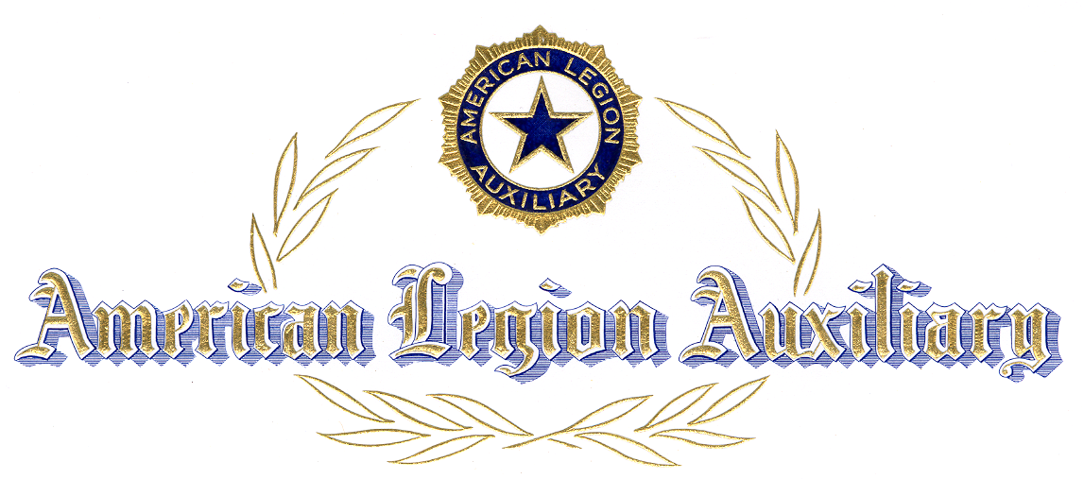

ROTC PROGRAM

PRESENTS THIS CERTIFICATE

TO:

OF:

IN RECOGNITION OF THE
OUTSTANDING ATTRIBUTES
DEMONSTRATED LEADING
TO THE AWARDING OF THE

AMERICAN LEGION AUXILIARY

MEDAL

SPONSORED BY UNIT NO.

PRESENTED BY

AT THIS DAY OF ,

