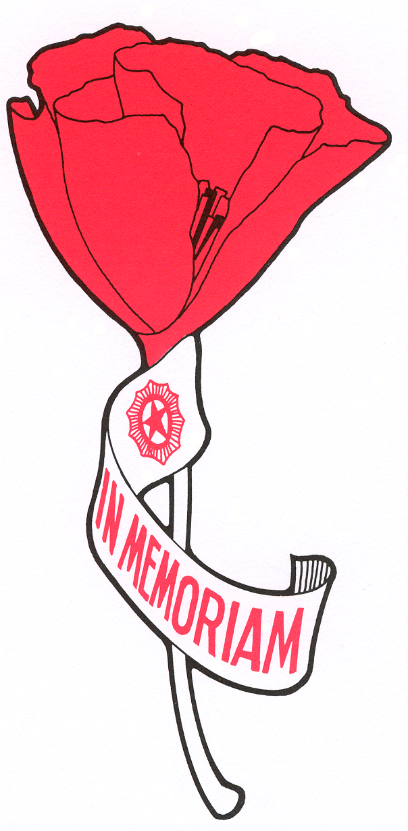

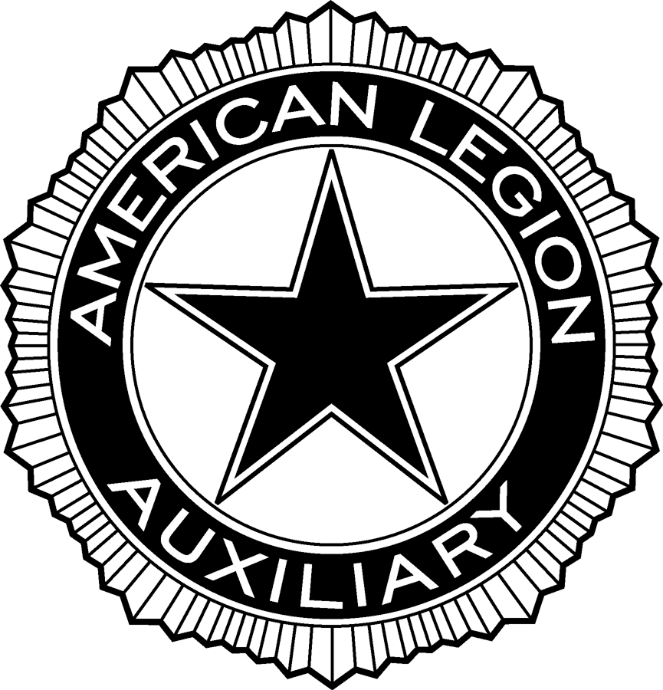

IN RECOGNITION

of

your outstanding support

of the

AMERICAN LEGION AUXILIARY

POPPY PROGRAM

On behalf of America’s veterans

thank you.

(Signature)

Unit

,

