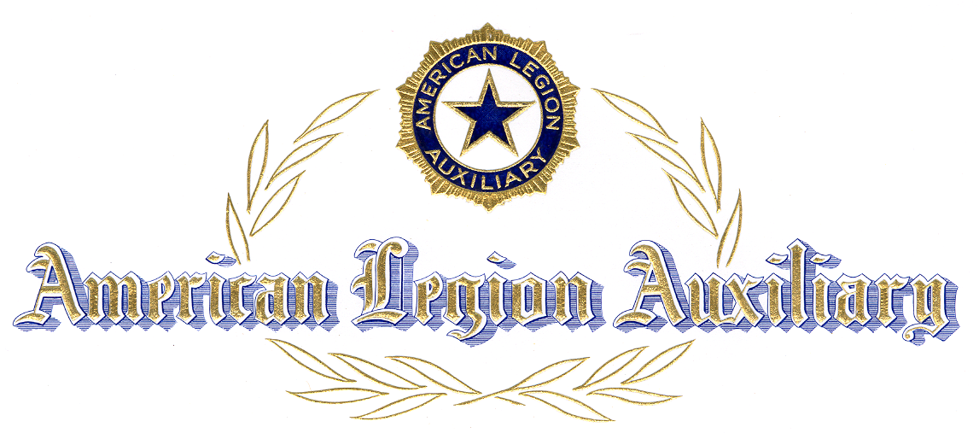
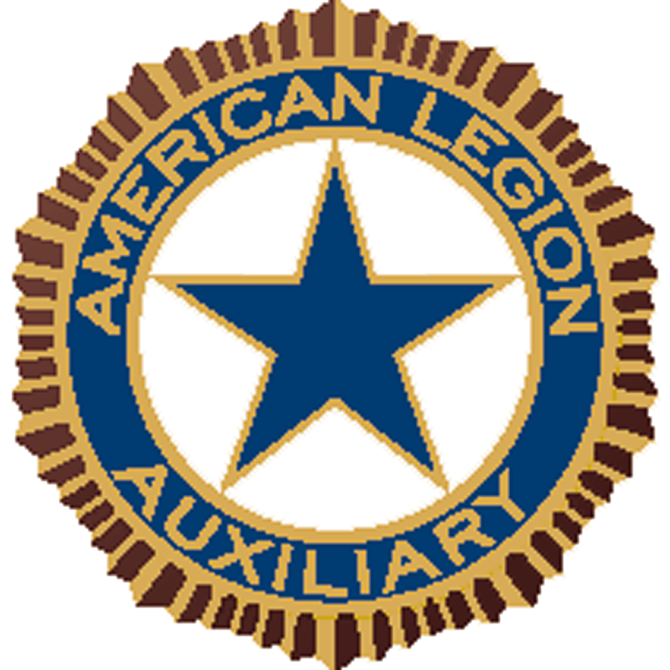

Citation
For

Meritorious Service

For Meritorious Service and Loyal Cooperation

of

is awarded this citation in recognition thereof by

Department of

American Legion Auxiliary

This day of ,

ATTEST:

________________________________________ ________________________________________

