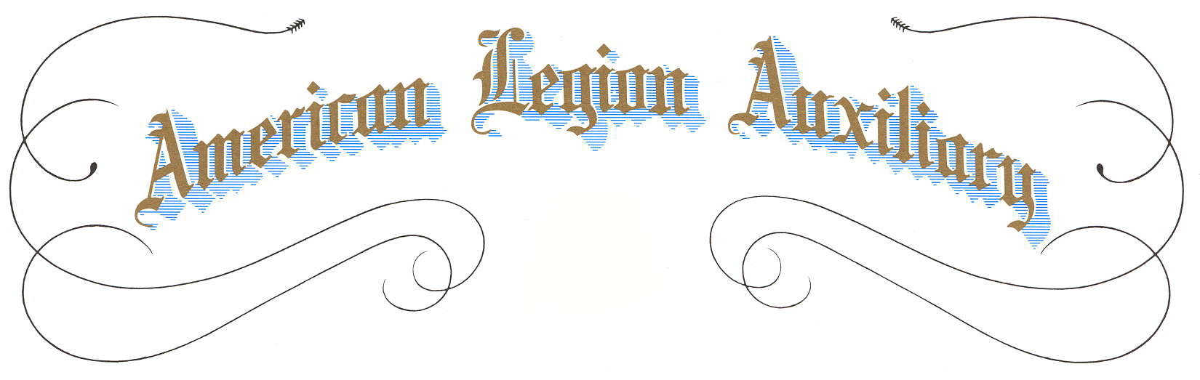

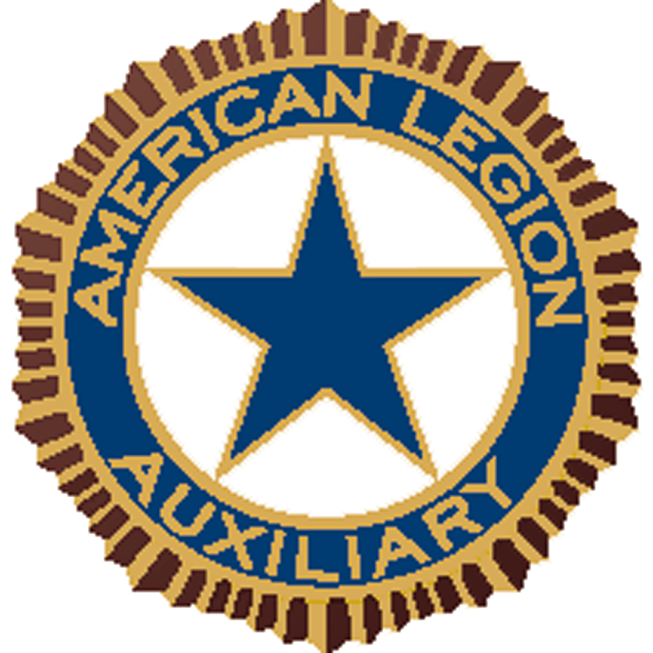




Presents This Certificate
To:

In Recognition Of The
Outstanding Attributes
Demonstrated Leading
To The Awarding Of The

AMERICAN LEGION AUXILIARY

Medal

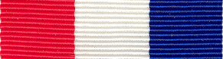

Presented by
AMERICAN LEGION AUXILIARY

This Day Of ,

________________________________________ ________________________________________

