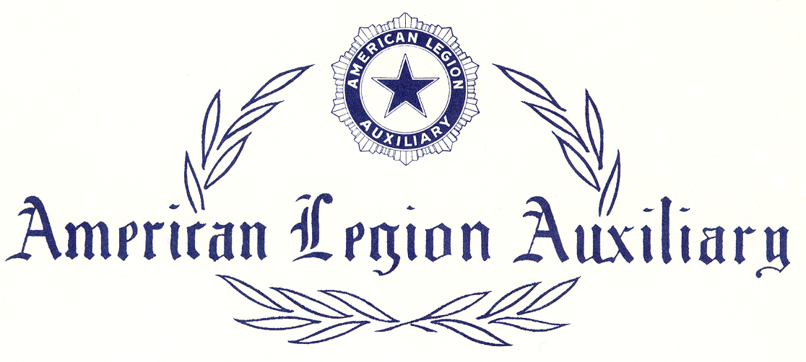

JUNIOR ACTIVITIES

Certificate of Participation

presented to

In recognition of participation in the
Department of
Junior Conference in the year

