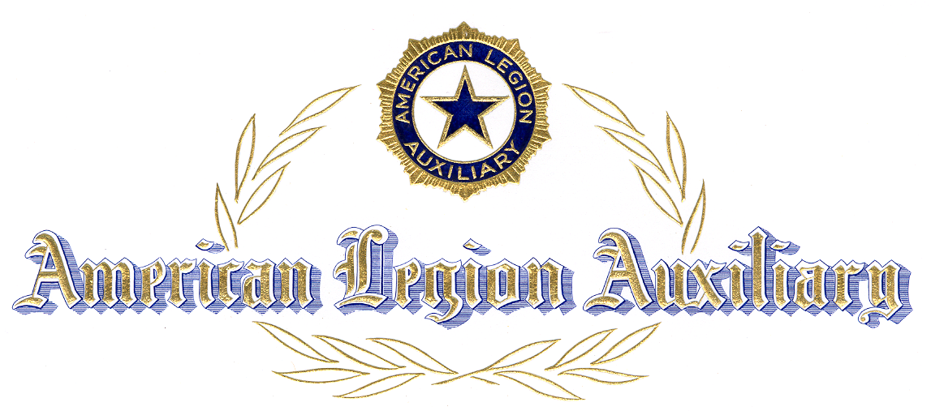
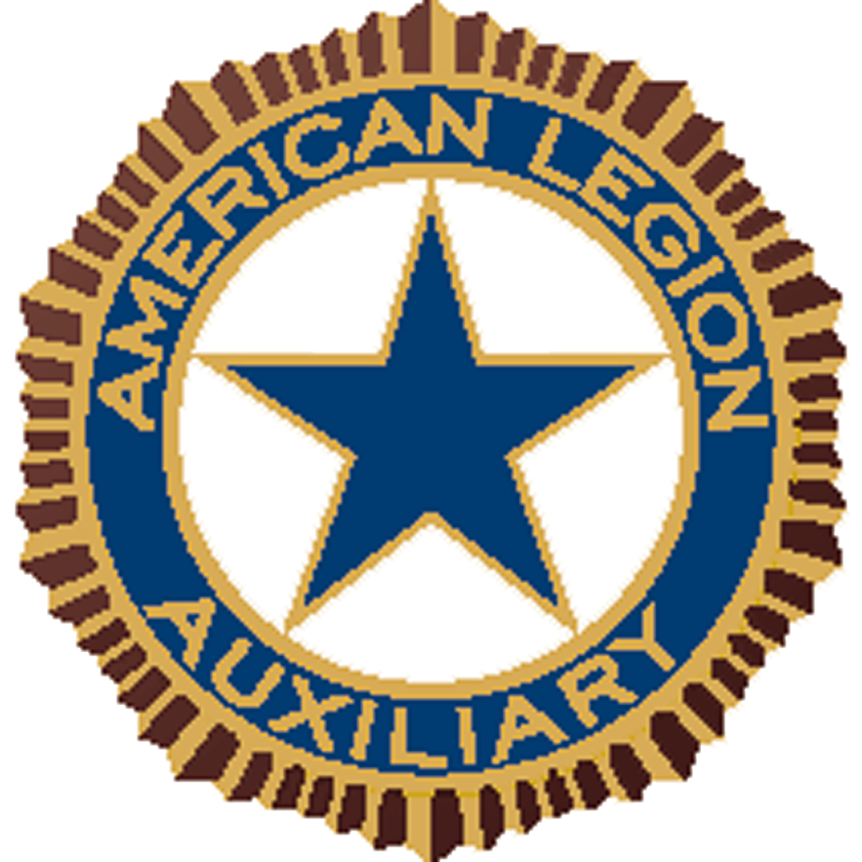

Certificate of Initiation

Presented To

To certify acceptance of membership in the
American Legion Auxiliary,
and to declare your eligibility to participate in and contribute to
the accomplishment of the aims and purposes of
the world’s largest patriotic women’s organization,
benefiting our Community, State, and Nation.

Presented by

Department of

This day of ,

ATTEST

________________________________________ ________________________________________
SECRETARY PRESIDENT

