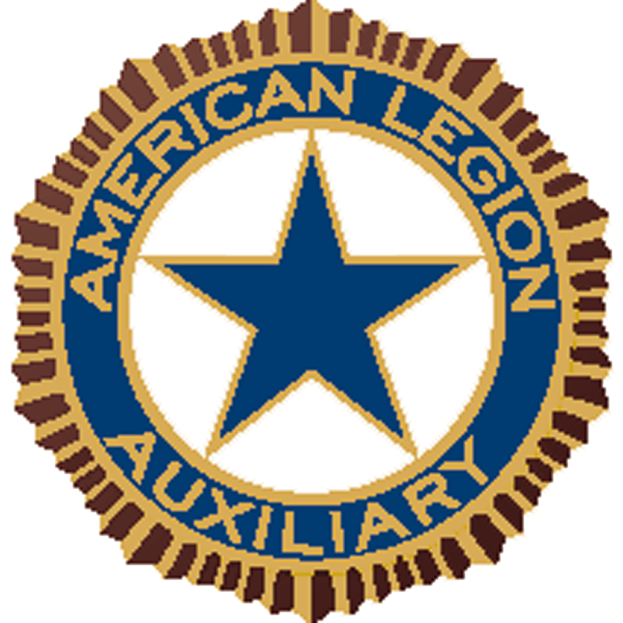
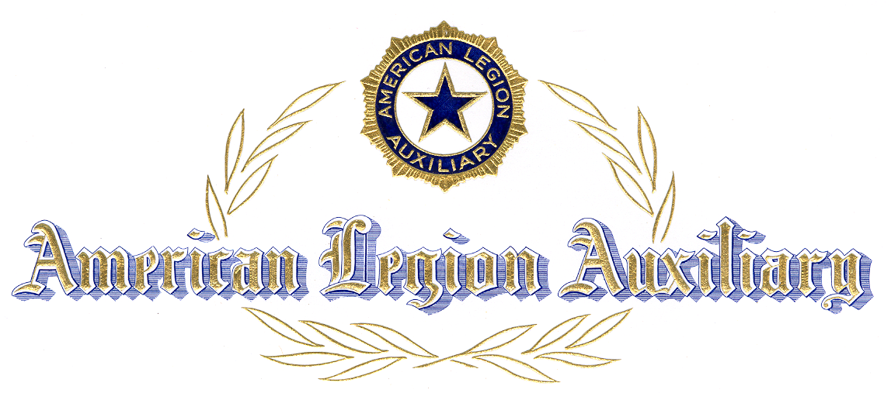

Certificate of Appreciation

PRESENTED TO

FOR

PARTICIPATION AND SUPPORT

OF THE

AMERICAN LEGION AUXILIARY

GIRLS STATE

CITIZENSHIP TRAINING PROGRAM

UNIT

Unit Girls State Chairman Unit President

