C O N T I N U O U S M E M B E R C E R T I F I C A T E

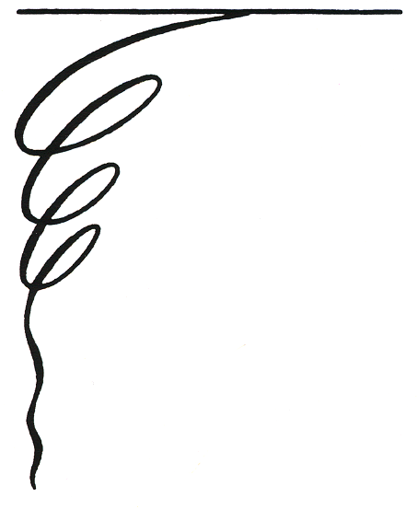
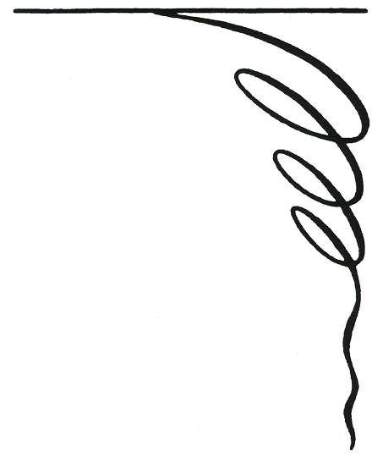

BE IT KNOWN THAT

PROPER ATTESTATION HAS BEEN PROVIDED TO THE EFFECT THAT

HAS BEEN A MEMBER IN GOOD STANDING
OF THE AMERICAN LEGION AUXILIARY
CONTINUOUSLY FOR THE PERIOD OF
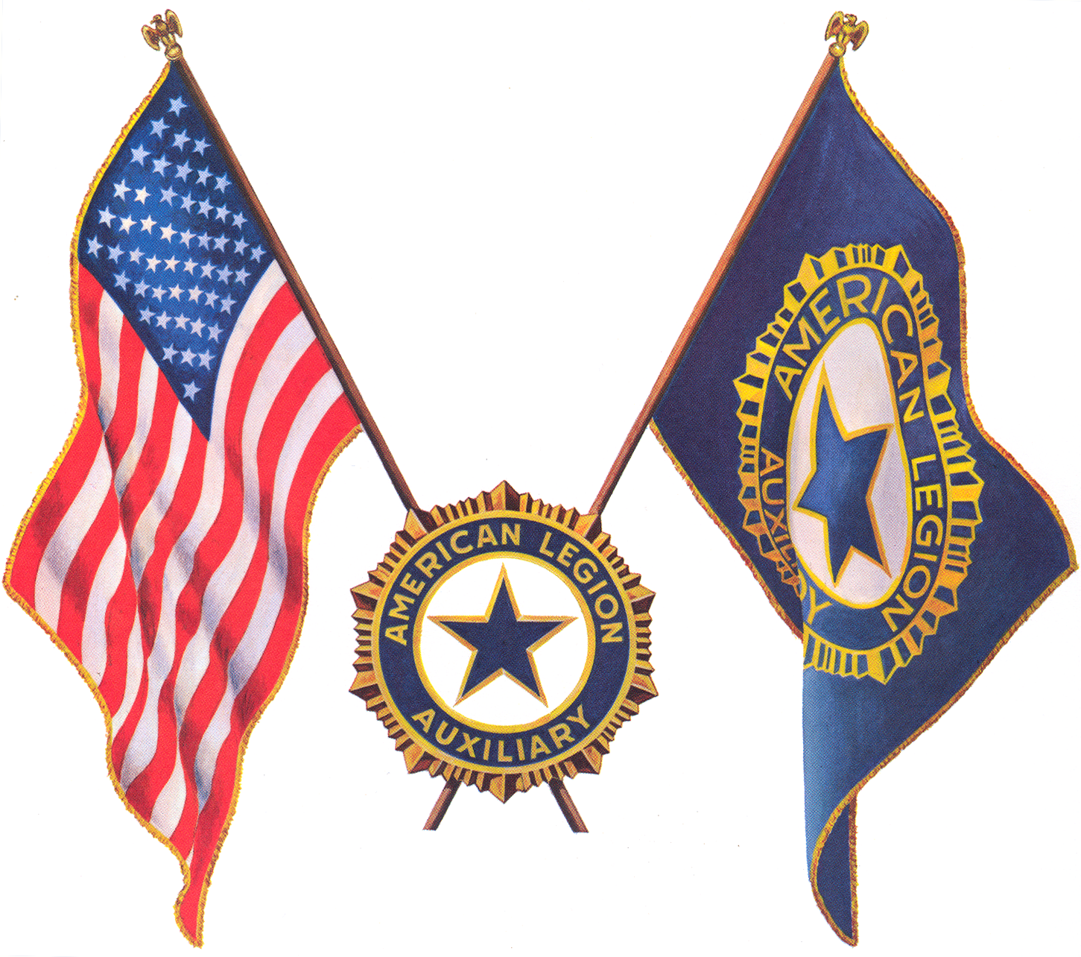


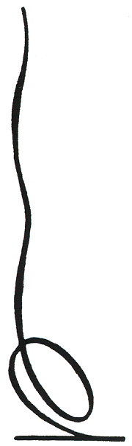
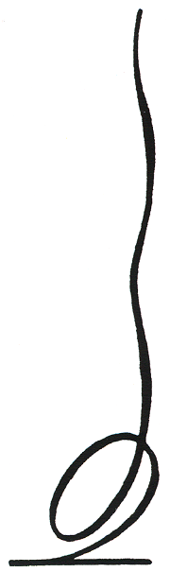

AND BE IT FURTHER KNOWN THAT SUCH
RECORD OF CONSISTENT LOYALTY TO
THE AMERICAN LEGION AUXILIARY
MERITS THE HONOR OF BEING CITED AS
AN OUTSTANDING CONTRIBUTOR TO THE
ACCOMPLISHMENT OF THE PROGRAMS
OF THE AMERICAN LEGION AUXILIARY.

,

ATTEST:___________________________________ ______________________________________
UNIT SECRETARY UNIT PRESIDENT

